create table Sailors(sid integer PRIMARY KEY,

sname varchar(20),rating integer,age integer,check(rating>=6 and rating<=10));

insert into Sailors values (1,'Jack Sparrow', 10, 40);

insert into Sailors values (2,'Will Turner', 6, 26);

insert into Sailors values (3,'Horatio', 7, 24);

insert into Sailors values (4,' Gibbs ', 9, 51);

insert into Sailors values (5,'Davey Jones', 10, 42);

insert into Sailors values (6,'Julius',9, 25);

insert into Sailors values (7, 'Dustin', 7, 45);

insert into Sailors values (8, 'Rusty', 10, 35);

insert into Sailors values (9, 'Horatio', 5, 35);

insert into Sailors values (10, 'Zorba', 8, 18);

insert into Sailors values (11, 'Julius',9, 25);

create table Boats(bid integer primary key,

bname varchar(50),

colour varchar(10),

check(bid>=100 and bid<=110));

insert into Boats values (100,'Black Pearl', 'black');

insert into Boats values (101,'Queen Annes Revenge', 'red');

insert into Boats values (102,'Blackbeards Delight', 'black');

insert into Boats values (103,'Redbeards Delight', 'red');

insert into Boats values (104,'Oceans Dagger', 'blue');

insert into Boats values (105'Marine', 'blue');

insert into Boats values (106,'Interlake', 'red');

select \* from Sailors;

select \* from Boats;

drop table Reserves;

create table Reserves(sid integer,bid integer,day varchar(20),primary key(sid,bid,day), foreign key(sid) references Sailors(sid),foreign key(bid) references Boats(bid));

insert into Reserves values (2, 101, '11-FEB-2016');

insert into Reserves values (6, 107, '10-JUN-2016');

insert into Reserves values (1, 101, '10-OCT-2016');

insert into Reserves values (1, 101, '10-OCT-2017');

insert into Reserves values (1, 102, '10-OCT-2017');

insert into Reserves values (1, 101, '10-JUL-2017');

insert into Reserves values (2, 102, '11-SEP-2017');

insert into Reserves values (2, 102, '7-NOV-2017');

insert into Reserves values (3, 101, '7-NOV-2017');

insert into Reserves values (3, 102, '7-AUG-2017');

insert into Reserves values (4, 103, '19-SEP-2017');

insert into Reserves values (6, 104, '19-SEP-2017');

select \* from Reserves;

1. select count(\*) from Boats where colour='black';

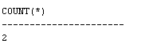

2.select Sailors.sid,Boats.colour from Sailors join Reserves on Sailors.sid=Reserves.sid join Boats on Boats.bid=Reserves.bid where Boats.colour='black' or Boats.colour='red';

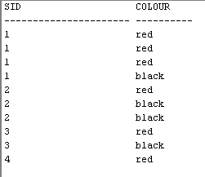

1. select sname,age from Sailors where age=(select min(age) from Sailors);

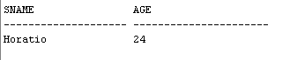

1. select distinct \* from Sailors natural join (select sid from Reserves where bid=101)T ;

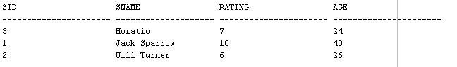

1. select Sailors.sname from Sailors where sid not in(select sid from Reserves) order by sname;

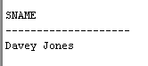

1. select colour from Boats join Reserves on Reserves.bid= Boats.bid join Sailors on Sailors.sid=Reserves.sid where Sailors.sname='Horatio';

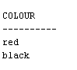

1. select count(\*) from Boats join Reserves on Boats.bid=Reserves.bid join Sailors on Reserves.sid=Sailors.sid where Sailors.rating=10 and Boats.colour='red';

